#.Find the transfer function from the following state equations

*1.*

*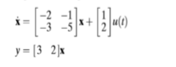*

*Matlab Code:*

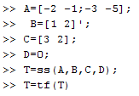

*Output:*

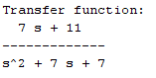

*2.*

*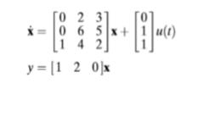*

*Matlab Code:*

*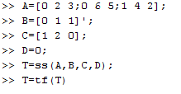*

*1.*

*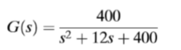*

*Matlab Code:*

*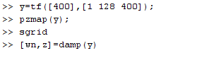*

*Output:*

*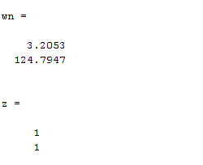*

*Figure:*

*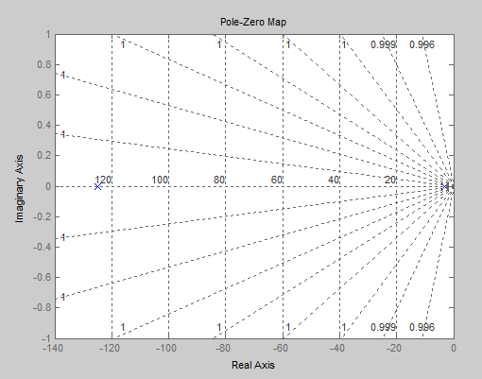*

*2.*

*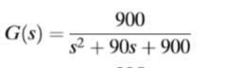*

*Matlab Code:*

*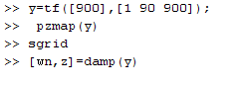*

*Output:*

*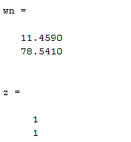*

*Figure:*

*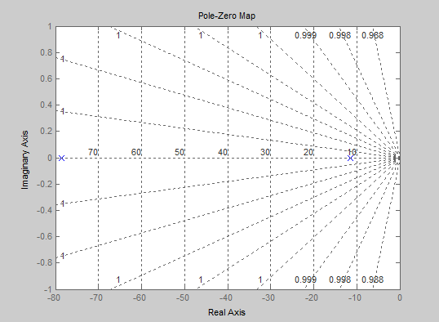*

*3.*

**

*Matlab Code:*

*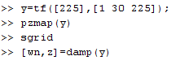*

*Output:*

*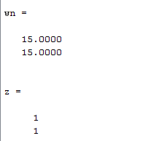*

*Figure:*

*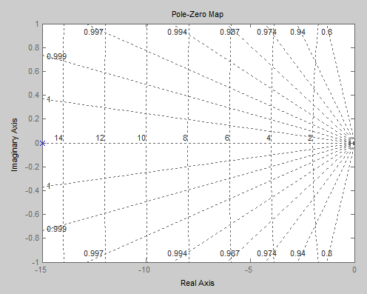*

*4.*

*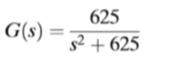*

*Matlab Code:*

*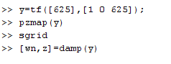*

*Output:*

*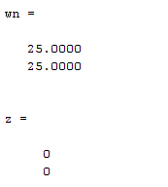*

*Figure:*

*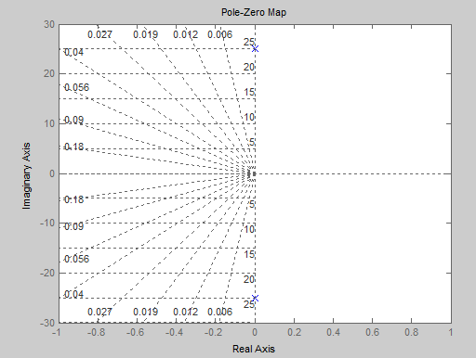*

#.Print a system when natural frequency (ωn) and damping ratio (ξ) are given

*1.*

**

*Matlab Code:*

*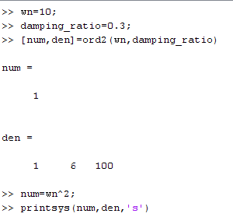*

*Output:*

*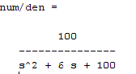*

*2.*

**

*Matlab Code:*

*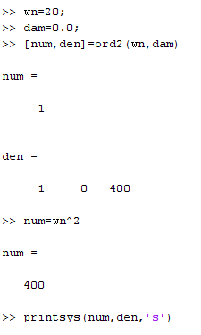*

*Output:*

*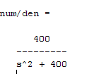*

*3.*

**

*Matlab Code:*

*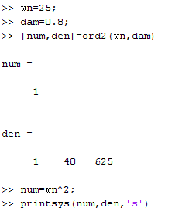*

*Output:*

*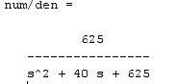*

*4.*

**

*Matlab Code:*

*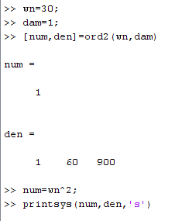*

*Output:*

*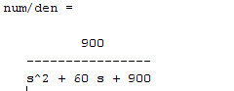*

#.Using MATLAB, obtain the unit-step response, unit-ramp response, and unit-impulse response of the following system

*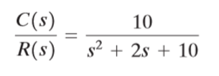*

*Unit Step Response*

*Matlab Code:*

*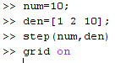*

*Output:*

*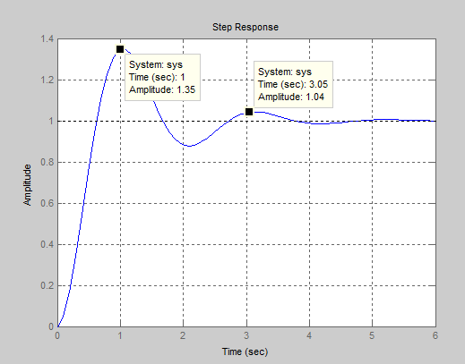*

*Unit Ramp Respoonse*

*Matlab Code:*

*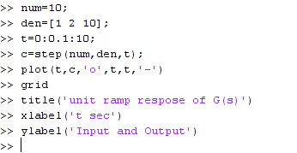*

*Output:*

*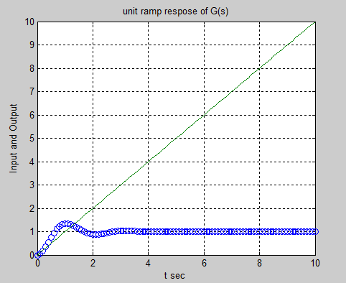*

*Unit Impulse Response*

*Matlab Code:*

*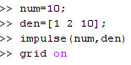*

*Output:*

*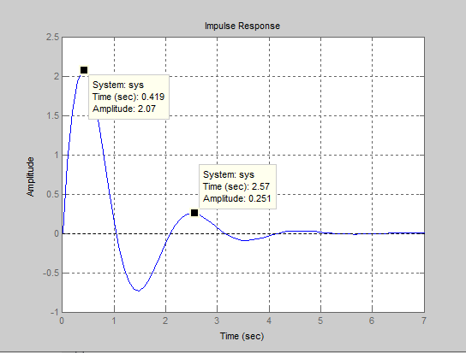*

#.Obtain the unit-ramp response of three transfer functions using “lsim” command

*1. $\frac{400}{s^{2}+90s+900}$*

*Matlab Code:*

*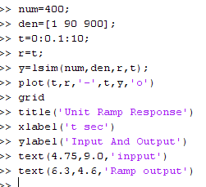*

*Output:*

*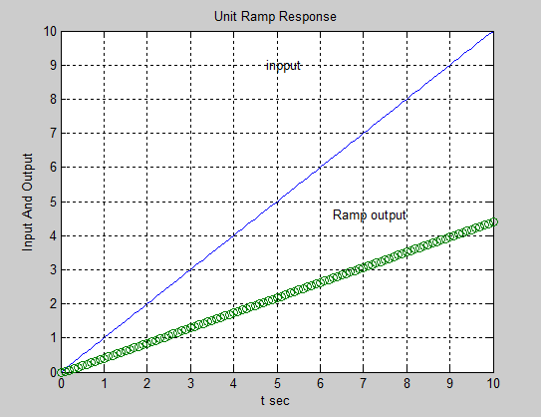*

*2. $\frac{400}{s^{2}+28s+400}$*

*Matlab Code:*

*. 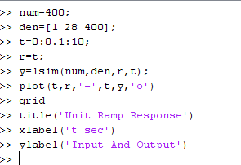*

*Output:*

*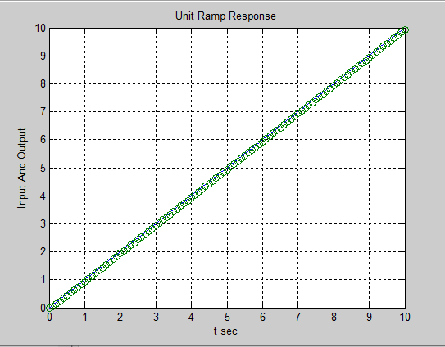*

*3. $\frac{10}{s^{2}+2s+10}$*

*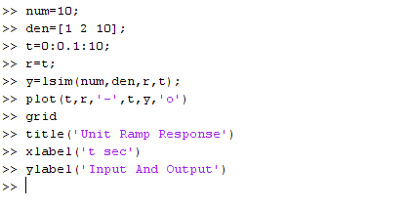Matlab Code:*

*Output:*

*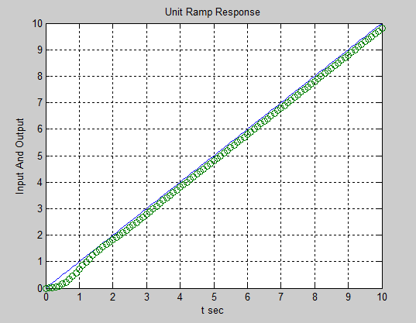*

#.Include step responses of overdamped, underdamped, critically damped and undamped system in a single figure using subplot command

*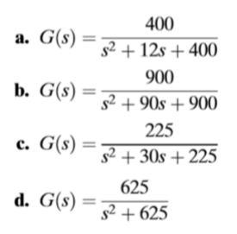*

*Matlab Code:*

*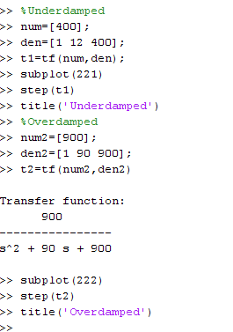*

**

*Output:*

*